JapFil
Foundation and Education
July 17, 2018

Irene Amore
Brgy. San Juan, Poblacion St.
Quezon City

Dear Irene Amore,
As you may know, our education foundation of the Japanese scholarship had reached 50 students per year. We would like you to enroll the JapFil Foundation and Education for the Japan’s preparation for foreign scholars. Our education had exciting lessons to learn basic writing and grammar, no boring lessons! It’s been 5 years of this program since 2013 and we would like you to join our community to Japan. This education program will lasts 1-2 years for education and learning and free visa for Japan. It’s our job to guide you to learn Japanese language and culture so that you may appreciate our community and study as much as you want. Thank you for enrolling JapFil education!

Sincerely,

Joshue de Leon Ph.D
Chairman

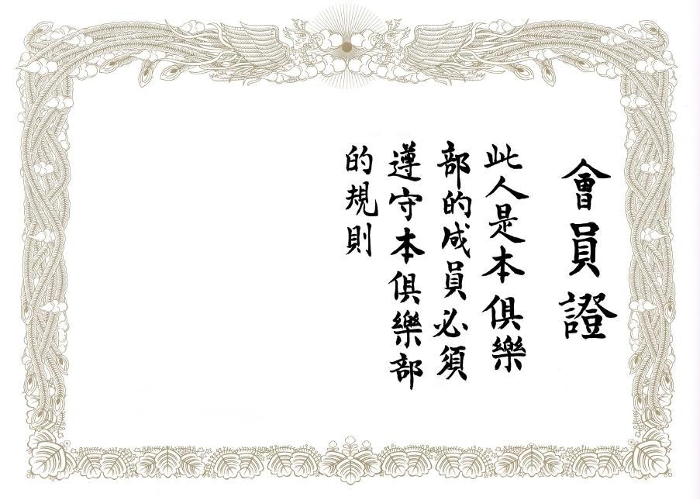
Irene Amore
Date: 2018/7/19
Joshue P. de Leon Ph.D
Chairman
JapFil

In Honor of Outstanding Performance
We Gladly Present
Certificate of Appreciation
With this Scholarship Award for Excellence in Japanese Language

